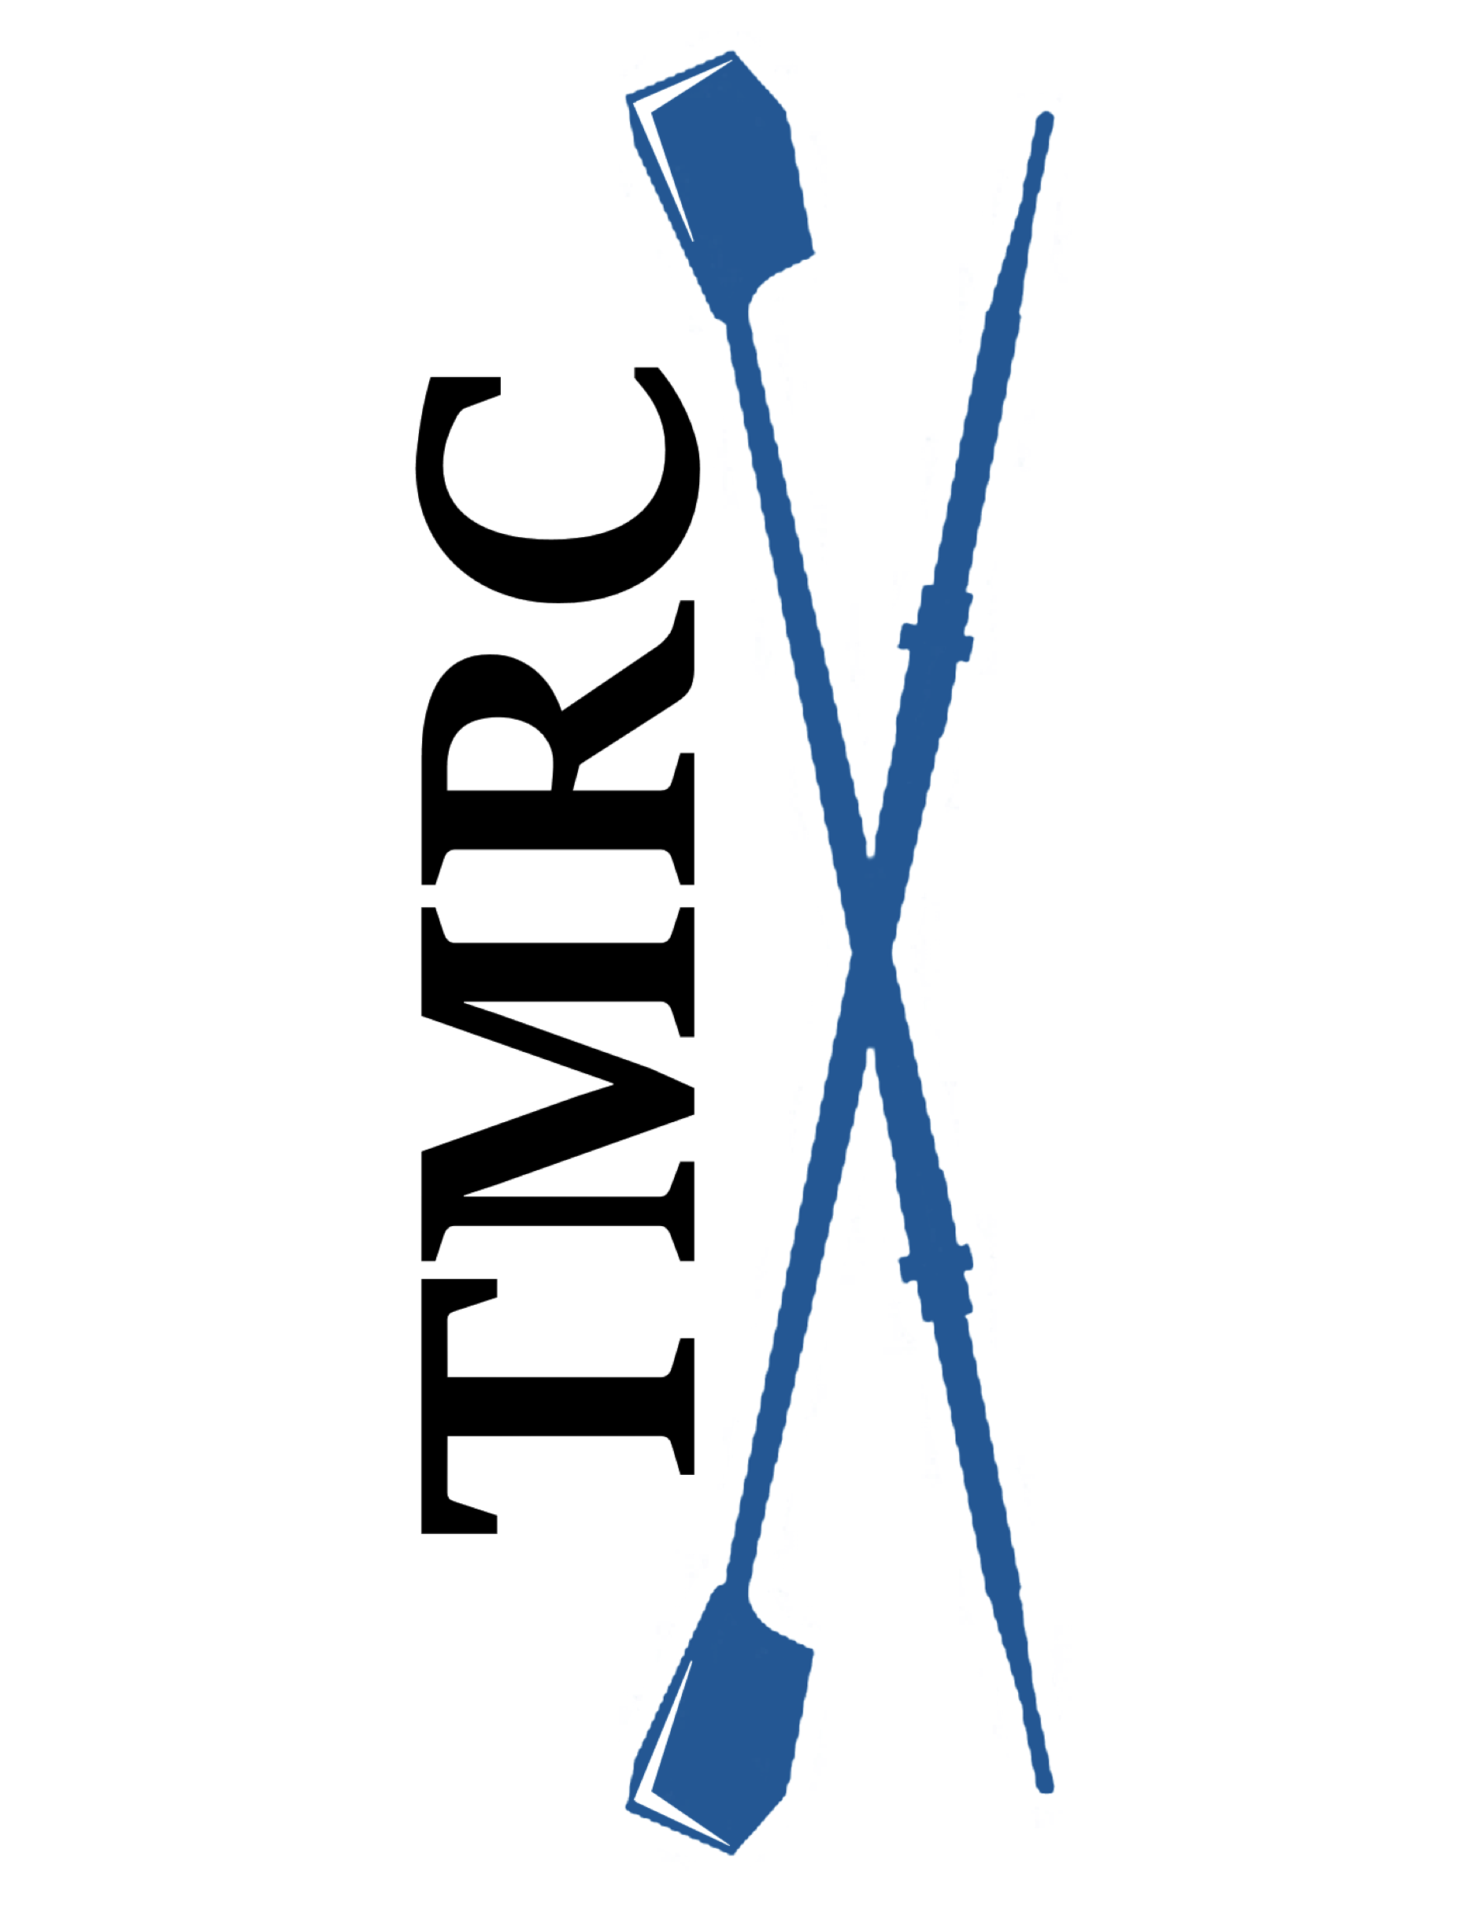
Table Mountain Rowing Club
“Learn to Row “Class Information

Are you athletic? Do you enjoy working closely with others? Do you have a love of water sports? Are you interested in participating in an amazing team sport?

Table Mountain Rowing Club is offering “Learn to Row” sessions this summer. Our Club is currently a competitive and recreational Masters Club. We are hoping to develop new Novice rowers and a couple of coxswains. No previous experience is required for either position.

Qualifications: Rowing is a very physical sport. You should:
- Be able to lift 35-40 lbs. above your head and also carry that weight on your shoulder.
- Be able to swim 100 yards and tread water for 10 minutes wearing athletic clothing.
- Be able to squat into a sitting position.
- Have good range of motion in your hips, knees and shoulders.
- Be at least 21 years old.

What to wear and bring: You will need to:
- Wear non-baggy exercise clothes such as leggings or spandex shorts.
- Exercise shirt/top (plan for the weather).
- Have socks to wear in the boat.
- Have tennis shoes for the indoor rowing machine.
- Bring non-metal water bottle(s) and a snack.
- Wear a hat, sunglasses and sunscreen.
- Be sure to bring your desire to work with others!

Paperwork and Homework: Once you are registered, you will need to bring the following completed items with you when you sign-in:
- Print and complete the TMRC Activities Participation form (liability waiver).
- Print and complete the Medical Consent form, in case of emergency.
- Print, complete and sign the Safety/Participation Acknowledgement form.
- Watch the US Rowing “Safety Video.” Print and complete the Safety Quiz after watching the first 28 minutes of the Safety Video.

Costs/Logistics:
- The cost is $75 for the Intro Learn to Row Session plus two additional Saturday sessions. Payment must be received ahead of time to reserve your spot. Cash or check made out to “TMRC” may be mailed to: TMRC, 702 Mangrove Ave., Box 181, Chico, CA 95926. We can also accept Zelle. Instructions will be provided when you register.
- The class will be held at the Forebay Aquatic Center, 930 Garden Dr., Oroville, CA.
- There is an additional charge of $8.00 for parking unless you have a pass with State Parks. Please stop at the kiosk at the entrance to purchase your pass. If using cash, they appreciate exact amount.
- Please be prompt and have your paperwork completed so that we can conduct sign-in and begin class instruction as quickly as possible.

Class Content:
- Sign-in time with collection of completed forms and fee.
- Review of US Rowing Safety Information.
- Overview of rowing equipment and terms.
- Introduction to correct rowing form using indoor Concept 2 rowing machines.
- On-the-water instruction in a large (multi-rower) sweep boat.

Health Precautions:
- Do NOT attend if you have a temperature, are feeling ill or have any COVID symptoms.

Masters Program:

TMRC Member fees are $225 quarterly which includes 3 weekly rowing sessions and coaching.
Although no swim test is required for our Learn to Row sessions, if you decide to become a member you will be required to complete a swim test prior to becoming a TMRC team member either as a Novice or more advanced rower. Swim tests need to be completed by a WSI (Water Safety Instructor). They were available through the Oroville YMCA, 1684 Robinson Street, Oroville, CA (530-533-9622) during water fitness and open swim times for a small cost. Please be sure a WSI is available wherever you choose to take the test. Be sure to take the “Swim Test” certificate, available on our website, with you to be signed. A flip test is necessary to row in single and double boats. The Flip test will be conducted by our coaching staff.

You also need to become a member of US Rowing. There are several membership packages available with the least expensive being $9.75 annually.

Rowing is the ultimate team sport! You must coordinate with others in your boat to achieve the best row possible! Every rower contributes!
We hope you decide to continue rowing with us.

