Table Mountain Rowing Club
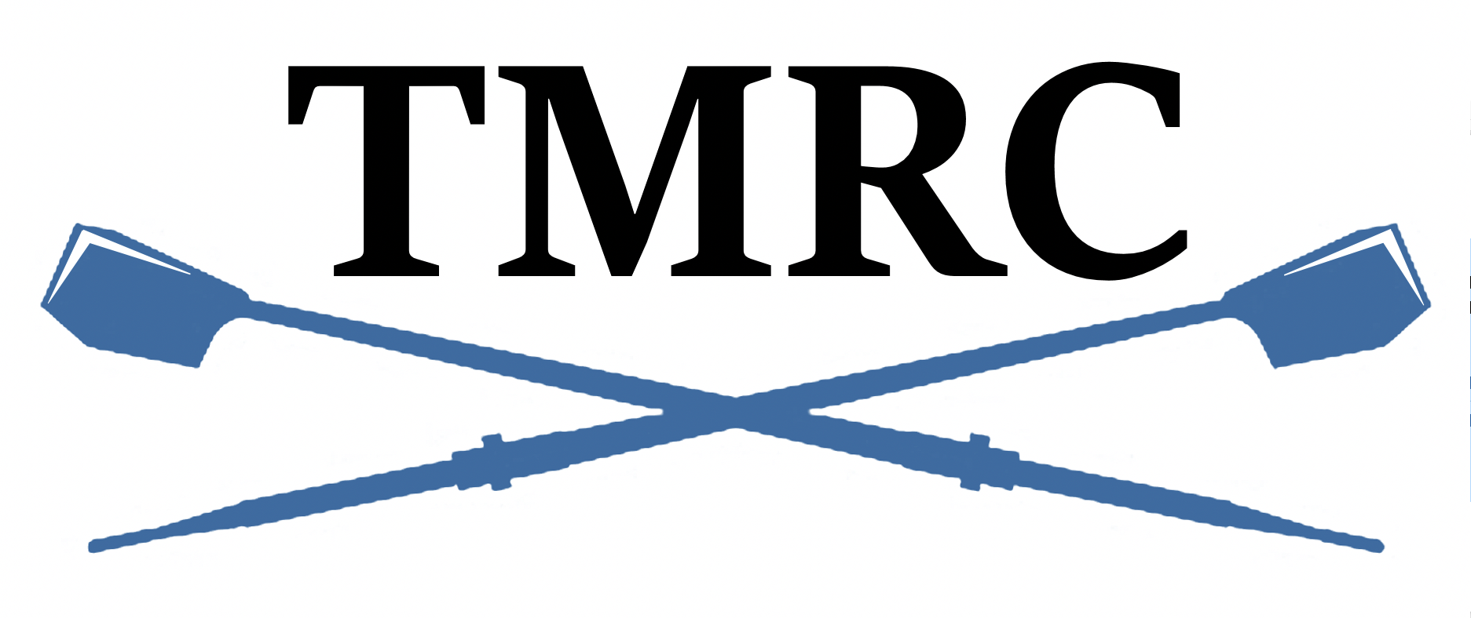
“Learn to Row” Safety/Participation Acknowledgement

LTR Rower: ______________________________________________________

Acknowledgement for ________________________________ (session date)

_____I have signed and turned in the TMRC Activities Participation (Liability Waiver) form.
_____I have completed, signed and turned in the Medical Consent form.
_____Prior to participating, I have watched and understood the US Rowing Safety video.
_____I have taken and turned in the TMRC Safety Quiz after watching the video.
_____I am able to lift 30-40 lbs. above my head and also carry that weight on my shoulder.
_____I am able to swim 150 yards and tread water for 10 minutes wearing athletic clothing.
_____I am able to squat into a sitting position.
_____I have good range of motion in my hips, knees, ankles and shoulders.
_____I have no medical conditions which would prevent me from participating in a physically strenuous activity.

I have completed all forms and feel prepared mentally and physically to participate in a Learn to Row session.

Signed: _________________________________________ Date: _________________________

Please bring this form, your TMRC Activities Participation form, your Medical Consent form and your TMRC Quiz with you.

