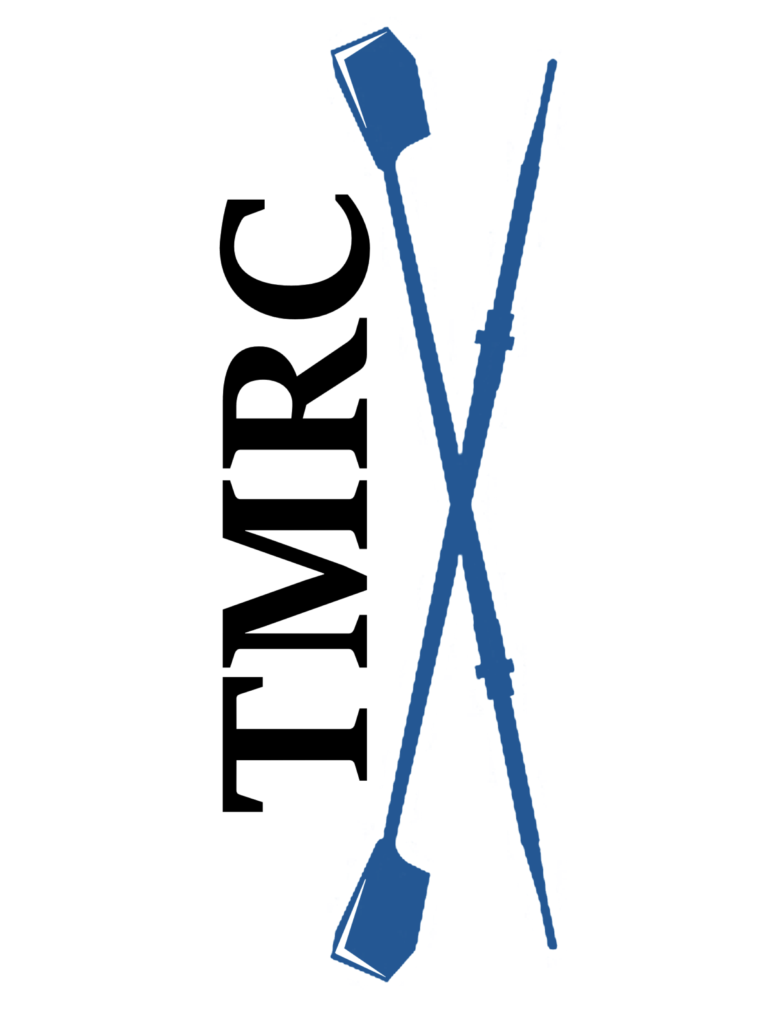
Table Mountain Rowing Club
“Learn to Row “Class Information

Are you athletic? Do you enjoy working closely with others? Do you have a love of water sports? Are you interested in participating in an amazing team sport?

Table Mountain Rowing Club is offering four “Learn to Row” sessions the weekend of May 22-23, 2021. Our Club is currently a competitive Masters Club. We are hoping to develop new Novice rowers and a couple of Coxswains. No previous experience is required for either position.

Qualifications: Rowing is a very physical sport. You should:
- Be able to lift 30-40 lbs. above your head and also carry that weight on your shoulder
- Be able to swim 150 yards and tread water for 10 minutes wearing athletic clothing
- Be able to squat into a sitting position
- Have good range of motion in your hips, knees and shoulders
- Be at least 21 years old

What to wear and bring: You will need to:
- Wear non-baggy exercise clothes such as leggings or spandex shorts
- Exercise shirt/top (plan for the weather)
- Have socks to wear in the boat
- Have tennis shoes for the indoor rowing machine
- Bring water bottle(s) and a snack
- Wear a hat, sunglasses and sunscreen
- Be sure to bring your desire to work with others!

Paperwork and Homework: You will need to bring the following completed items with you when you sign-in:
- Print and complete the TMRC Activities Participation form (liability waiver)
- Print and complete the Medical Consent form, in case of emergency
- Print, complete and sign the Safety/Participation Acknowledgement form
- Watch the US Rowing “Safety Video” and complete the written quiz so that you come prepared with that knowledge

Costs/Logistics:
- The cost for the four hour “Learn to Row” session is $25.00. Cash or check made out to “TMRC” is accepted. There is an additional charge of $8.00 for parking unless you have a pass with State Parks.
- The class will be held at the Forebay Aquatic Center, 930 Garden Dr., Oroville, CA.
- Please be prompt so that we can begin sign-ins and class instruction as quickly as possible.

Class Content:
- Sign-in with collection of completed forms and fee
- Review of US Rowing Safety Information
- Overview of rowing equipment and terms
- Introduction to correct rowing form using indoor Concept 2 rowing machines
- On-the-water instruction in a large (multi-rower) sweep boat

COVID Precautions:
- Do NOT attend if you have a temperature or any COVID symptoms
- Bring a face mask for when we may be in close quarters

Masters Novice Program:
If you decide that rowing appeals to you and is something you are interested in continuing, we encourage you to join our Novice group. They will be meeting Monday and Wednesday for a practice session starting at 5:30pm. A Saturday session may also become available.

Novice rowers who join our team will be required to complete a swim test and a flip test prior to joining the team. Swim tests are available through the Oroville YMCA, 1684 Robinson Street, Oroville, CA during water fitness and open swim times for a cost of $10. Please call them at 530-533-9622 to arrange a time when a WSI (Water Safety Instructor) is available. Be sure to take the “Swim Test” certificate, available on our website, with you to be signed. The Flip test will be conducted by our coaching staff.

Our Membership Fee is $150 per quarter (three months) with an additional $150 for coaching/expense fees. For those joining us in June, you would only be required to pay $50 for Membership and $50 for coaching. The next quarter would start with July-August-September and would require the full fee by July 5.

Rowing is the ultimate team sport! You must coordinate with others in your boat to achieve the best row possible! Every rower contributes!
We hope you decide to continue rowing with us.

